

ATAR CHEMISTRY UNITS 1 AND 2
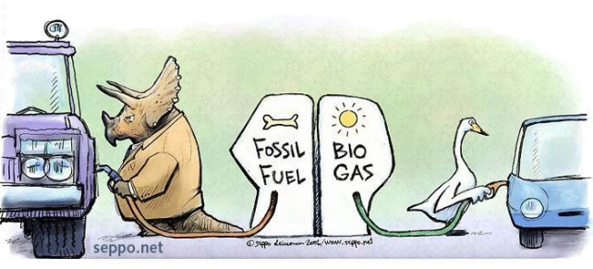
Extended Response: Fossil Fuels and Biofuels
Weighting: 5%
Validation Test Date:

Task: This task is divided into three parts (Leinonen nd)
- Complete the following research questions.

- Complete the table below on the fossil fuels and biofuels given. For fuels that are a mixture, give the most common component or a typical component of the fuel.

Fuel | Main Component Name/Formula | Energy Output  (kJ g⁻¹) | Energy Output  (kJ mol⁻¹)
Coal |  | 29
Petroleum |  | 43
Petrodiesel |  | 43
Natural gas |  | 45
Biodiesel |  | 38
Bioethanol | Ethanol / C₂H₅OH | 27

- Determine the amount of carbon dioxide produced in grams for every MJ of heat released (g(CO₂) MJ⁻¹) in the complete combustion of each of the fuels given in the table. You must show full working.

- Using the values from Q2, decide which is the most and which is the least environmentally friendly fuel.

- Comment on the assumption that during a combustion reaction a fuel is reacted with oxygen to produce carbon dioxide and water vapour only. What other products may be produced. Give reasons for your answer.

- Give correctly referenced sources you have used to get information (you must use at least two sources).

- Complete Set 22 Q10-14a). Use 13.8-13.10 from Essential Chemistry as a reference.

- You will be tested on this work in class under strict test conditions.

Bibliography
Leinonen, Seppo. “Fossil Fuel - Biogas.” Sepponet Environmental Cartoons. nd. http://www.seppo.net/cartoons/displayimage.php?pid=736 (accessed May 13, 2015).

- You will need to read pages 103 (13.8 Fuels: The Energy Source for a Modern Economy) – 107 in Essential Chemistry Australian Chemistry for Western Australia: ATAR Chemistry Units 1 + 2 (Lucarelli) and then complete Set 22 questions 10 – 14 (pages 110 – 111).

- You will be tested on a selection of these questions in class under strict test conditions.

Bibliography
Biomass Energy Centre. “Carbon Emissions of Different Fuels.” Biomass Energy Centre. 2012. http://www.biomassenergycentre.org.uk/portal/page?_pageid=75,163182&_dad=portal&_schema=PORTAL (accessed May 25, 2015).
Blake. “Mrs Blake's Chemistry.” Anoka-Hennepin Schools. n.d. http://moodle.anoka.k12.mn.us/course/view.php?id=606&section=2 (accessed January 30, 2015).
Leinonen, Seppo. “Fossil Fuel - Biogas.” Sepponet Environmental Cartoons. nd. http://www.seppo.net/cartoons/displayimage.php?pid=736 (accessed May 13, 2015).
The Engineering Toolbox. “Combustion Fuels - Carbon Dioxide Emissions.” The Engineering Toolbox. nd. http://www.engineeringtoolbox.com/co2-emission-fuels-d_1085.html (accessed May 25, 2015).
Wikimedia. “Energy Content of Biofuel.” Wikipedia. 2015. http://en.wikipedia.org/wiki/Energy_content_of_biofuel (accessed May 25, 2015).
Woodford, Chris. “Car Engines.” Explain That Stuff. 20 March 2015. http://www.explainthatstuff.com/carengines.html (accessed May 25, 2015).

